User Manual Specification
Release Version -1.1
For
Meghna Solar Ltd.
Concern Topic: Employee Management

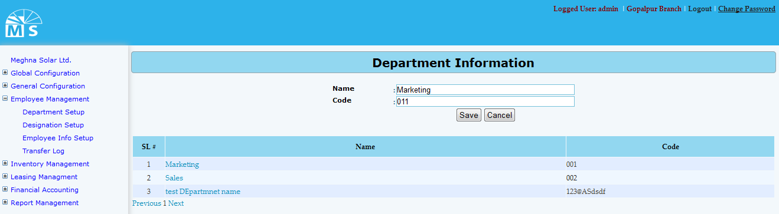

Department Info Setup

Here user needs to enter Department name and Code in the text box and click Save Button to save Department information. Recently saved Department information will be visible in the below grid view. For updating any information user need to click on the Department name in the grid view. Then after modifying the Department info in the Upper text box, user need to Press Update button. After that, modified Department information will be available in the grid view.
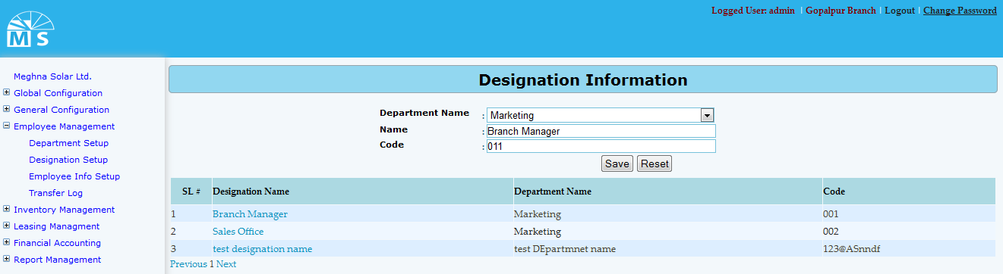

Designation Info Setup

Here user needs to select Department name from the dropdown list. Then enter Designation name and code in the text box and click Save Button to save Designation Information. Recently saved Information will be visible in the below grid view. For updating any Designation information user need to click on the Designation name in the grid view. Then after modifying the information, user need to Press Update button. After that, modified Designation information can be seen in the grid view.
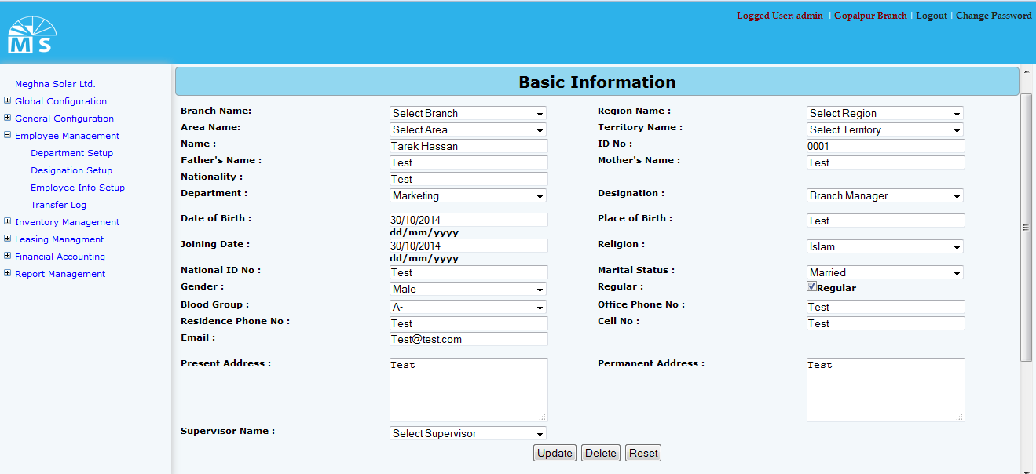

Employee Info Setup(Basic Information)

Here user needs to enter Employ’s basic information. For that top of the entry form user need to select Branch, Region, Area and Territory name from the dropdown list. Then user need to entry employ’s name, ID no., Employ’s Father’s name, mother’s name and nationality in the text box . After that user need to select department name and Designation from drop down list and enter Date of birth, place of birth and Joining Date. Then after selecting religion,Maritial Status, gender and blood group from drop down list user need to enter National Id no., employ’s contact no., email address, present and permanent address in the text box.At last User need to select a Supervisor of that emplyee from Supervisor name drop down list .

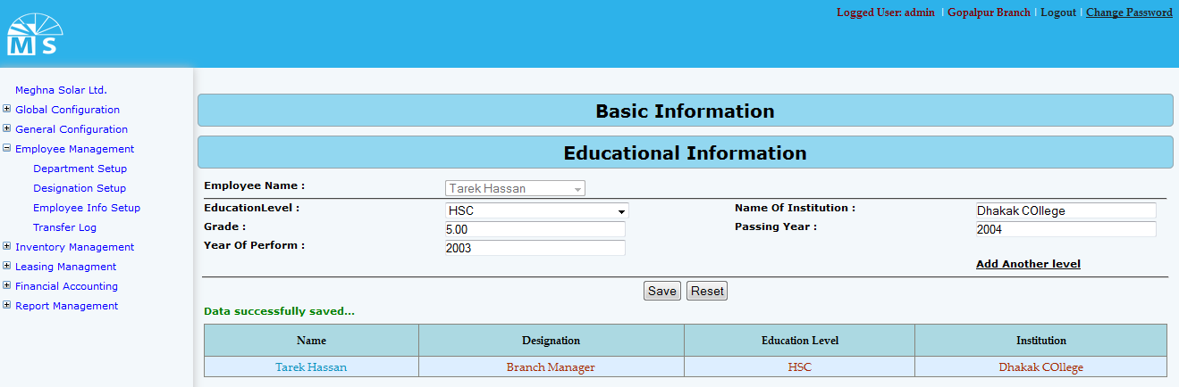

Employee Info Setup(Educational Information)

For entering educational information of an emplloyee user need to select employee from Employee dropdown list. Then for each education level user need to selelct from drop down list (ex: JSC, SSC, HSC, Masters etc.). User also need to enter Institution name, Grade,Passing Year and year of Perform in the following text field.
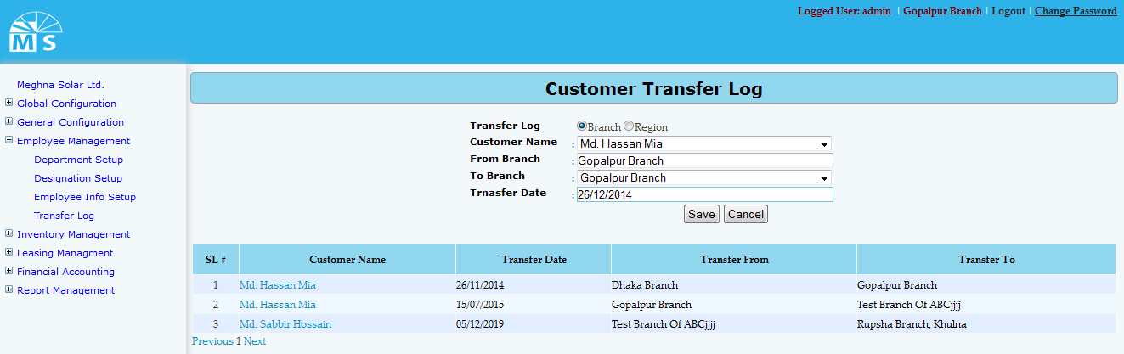

Customer Transfer Log (Branch wise)

Here user first needs to decide whether to insert data Branch wise or Region wise. According to that, branch and region should be sellected from the top radio button sellection. Then user need to select Customer name from the dropdown list. After that user need to enter From and to branch and transfer Date in the text boc and click Save Button to save transfer log. Recently saved Transfer Log will be visible in the below grid view. For updating user need to click on the Customer name in the grid view. Then after modifying the info in the text box, user need to Press Update button. After that, modified Transfer Log information can be seen in the grid view.

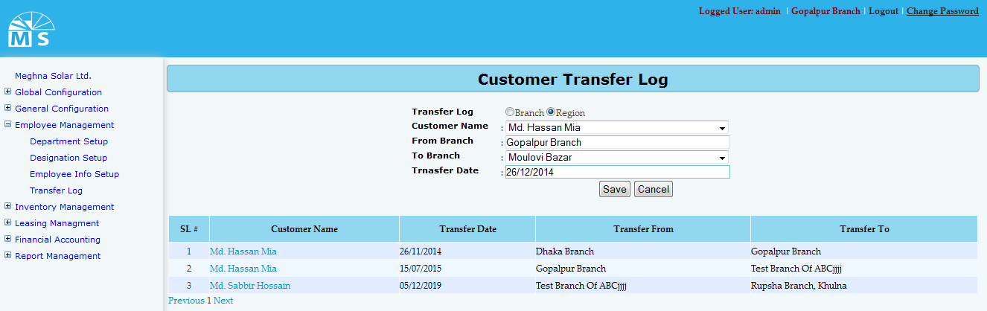

Customer Transfer Log (Region wise)

Here user needs to select Region from the second drop down list, enter other information and click Save Button to save Customer Transfer Log. Recently saved information will be visible in the grid view. For updating any informartion user need to click on customer name in the grid , modify info in text box and click update button to see modified info in the grid view.

